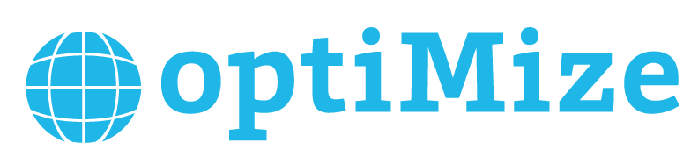
Core Team Application 2016-2017
Complete and return to anyacho@umich.edu by September 21 at 11:59pm

optiMize unites students who are passionate about social change and want to take action. Our supportive community provides students with resources that make it possible to turn ideas into impact.

Through our Social Innovation Challenge and Summer Fellowship Program, we annually provide over $150,000 in funding which allows our teams to continue innovating toward a better world. We encourage ourselves to push boundaries and take on new challenges by always asking, "Why not me?"

The optiMize community is made up of hundreds of students, faculty, alumni, and community leaders, and none of this would be possible without the dedication and passion of our Core Team.

The Core Team
The optiMize Core Team is a group of change-driven, motivated students who consistently use their talents to create a better community. Core team members work on a variety of projects such as planning workshops and Innovate Nights for our Social Innovation Challenge, building relationships with mentors and community leaders, and creating content and promotional materials for our events. All Core Team members have the opportunity to personalize impact in our community.

Who are we looking for?
We want individuals who are passionate about creating a community of social innovators and are willing to take initiative and engage with the community. We believe in the value of diverse perspectives and appreciate people of all backgrounds, interests, and talents.

What are we asking of you?

- 4-8 hours a week
- Punctual attendance and participation at weekly events and Core Team meetings. Core Team meetings will take place every Sunday.
- Consistent and clear communication
- Positive representation of our organization and community

Application Guidelines

- Due on Wednesday, September 21 by 11:59pm EST
- Applicants must answer all questions
- Applicants are not required to submit a resume along with their applications, but it is highly recommended
- Please compile your application and resume into one document, then email it as an attachment named “LastName.FirstName_CoreTeamApplication.pdf” Please save as a PDF.
- If you are selected for an interview, we will contact you to set up a time
  - Interviews will take place September 22nd -28th
- Email this document and any questions to Anya Cho, VP of Operations: anyacho@umich.edu with the subject line,
“Core Team Application: [First Name] [Last Name]”

Core Team Application 2016-2017

General Information
Name:
Phone Number:
Email Address:
Planned Graduation Year:
School of Enrollment:
Major(s):
Minor(s):

Why do you want to be on the optiMize Core Team?

- What can you bring to the optiMize community?

- Describe an experience that required you to step up as a leader. What did you do and how did you learn from that?

- What do you think is the best way to create strong relationships among team members?

- As an organization, we maintain strong community values and emphasize the importance of relationships. Describe your ideal team culture in three words:

- What are your time commitments for this school year? Please include student organizations, jobs, study abroad, etc.
- Is there anything else about yourself that you want to share, including any specialized skills?

Thank you for taking the time to fill out this application. We will contact you in the next few days. Please direct questions to Anya Cho at anyacho@umich.edu

